Title of Paper

Johann S. Bach1, Martin Dupont2 and Frank Zappa2

1 Institute/Company, City (Country)

2 Institute/Company, City (Country)

**Abstract**

Include a short summary of your paper here. The summary should be between 10 and 15 lines, and should include keywords.

*Keywords: Type your keywords here, separated by commas,*

1. Introduction

This is both a guideline and a template for preparing your manuscript for the SWC 2021 conference proceedings. To format your manuscript correctly, use the fonts and type sizes, as well as paper settings defined in this document. The manuscript must be uploaded both as a **.pdf** and .as a **.docx** file to the Solar World Congress 2021 website at <http://www.swc2021.org>. The length of the paper may not exceed 12 (twelve) pages; otherwise it cannot be uploaded!

All papers can be submitted in electronic form only to the SWC 2021 website author center at https://www.swc2021.org/ and must be submitted no later than **15 October 2021.**

1. Paper formatting

The manuscript must be written in English. The paper title should be written in Arial, 14 point, bold. The section headings should be numbered, in **Arial 12 pt bold**, the sub-sections in Times New Roman11 pt. The standard font for the manuscript is Times New Roman for the text and Symbol for special characters. Body text should be justified as block, 10 pt, in single column format. Line spacing is at multiple of 1.15

The paper size is A4 (210 mm x 297 mm). Margins are 19.0 mm top; 25.4 mm right and bottom and 30.0 mm left. **Do not change the paper formatting and do not insert page numbers, headers or footers!** Papers using incorrect formatting may be rejected for publication in the proceedings if the author does not make corrections. References must be formatted exactly as shown in the examples given below. The sections and sub-sections must be numbered by the author(s); do not use automatic paragraph numbering.

Please use the styles that are defines in the Word Document (under the Style Menu) to format the text instead of directly setting the fonts. The styles are

* *SWC_heading1* for first level section headers
* *SWC_heading1.1* for second level section headers
* *SWC_text* for the body
* Styles for table and figure captions.

This will ensure that the margins for the sections are also correct and will result in less work for you and a consistent layout for our conference proceedings.

1. Tables, figures, equations, and lists

3.1. Tables

All figures and tables must be cited in the text, numbered in order of appearance and followed by a centered title. Each table column should contain a brief explanatory heading.

Tab. 1: Table captions (8 pt) should be justified as block and placed above the table

|  |  |  |
| --- | --- | --- |
| **Table Header** | **Header** | **Header** |
| Tables | Text | Text |

3.2. Figures

Figures should be submitted with a resolution of minimum 300 dots per inch and followed by a figure caption, justified as block. Please make sure that the axes and any text within the figure are legible with a minimum font size of 8.

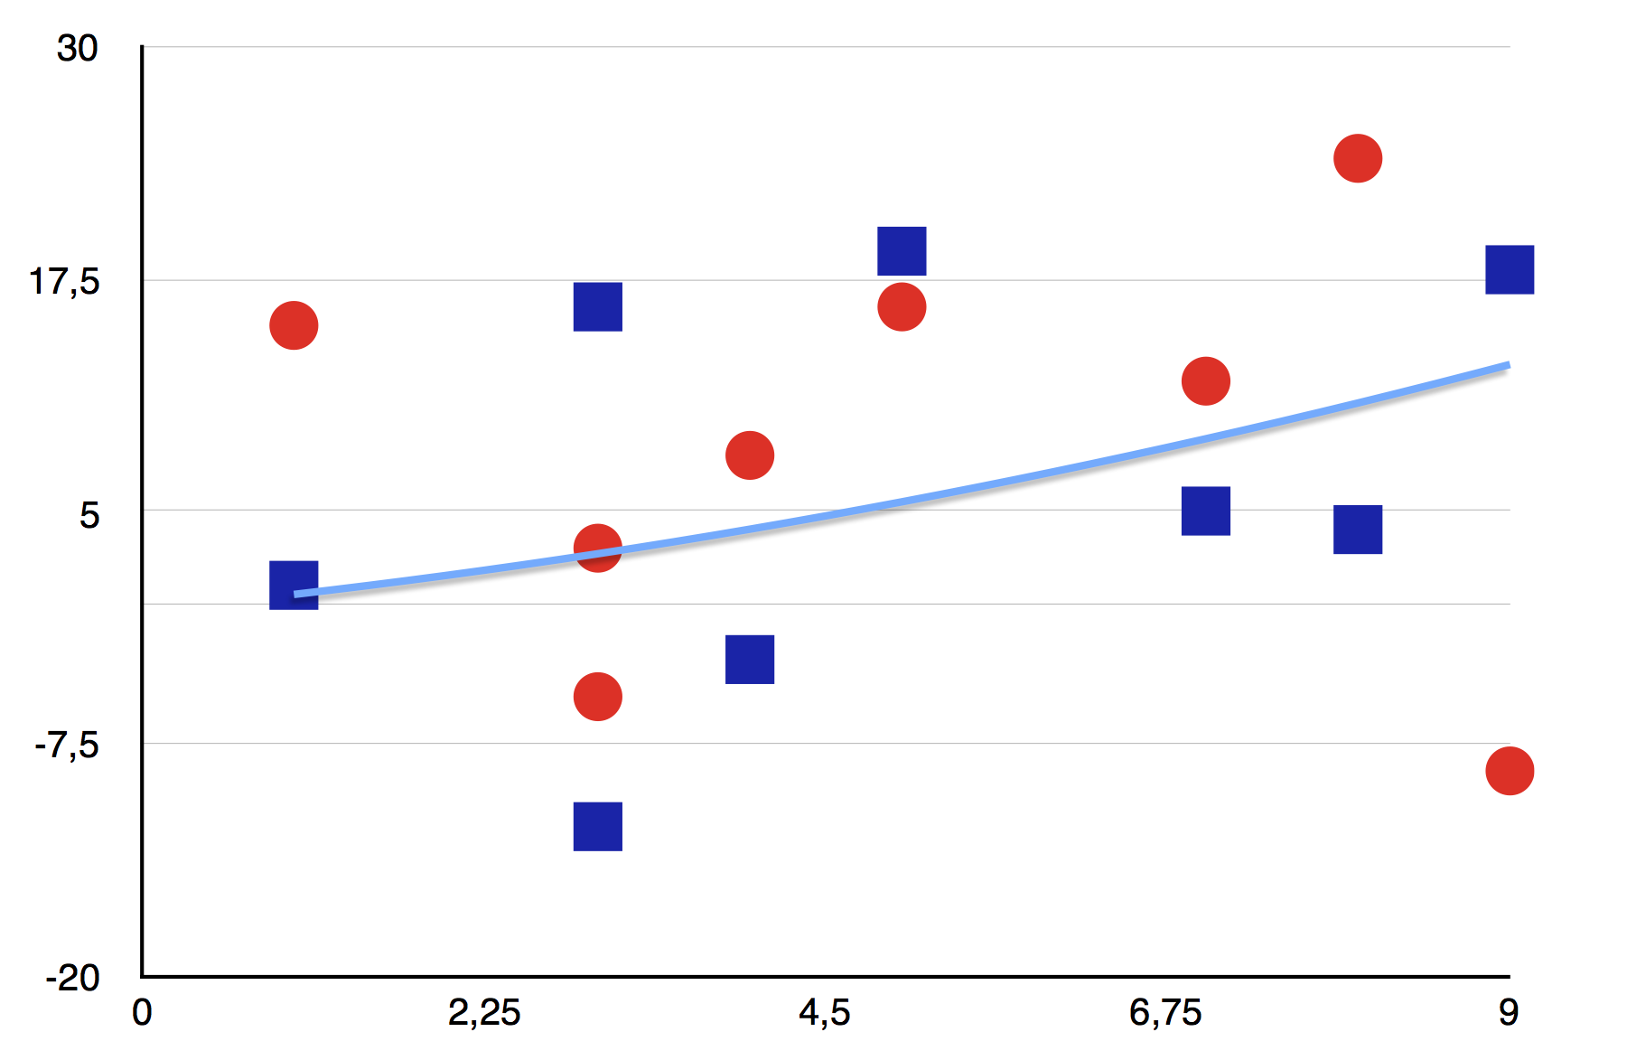

Fig. 1: Figure captions (8 pt) should be justified as block and placed below the figure

3.3 Equations

Equations should be arranged to the left, with characters similar to that of the body text and should be numbered.

$\frac{1}{2π}\int_{0}^{2π}{\frac{ⅆθ}{a+b\sin{θ}}}=\frac{1}{\sqrt{a^{2}-b^{2}}}$ (eq. 1)

$\sin{α}±\sin{β}=2\sin{\frac{1}{2}\left(α±β\right)}\cos{\frac{1}{2}\left(α∓β\right)}$ (eq. 2)

3.4 Lists

* Bulleted lists can be used to arrange information more clearly in the text.

1. Acknowledgments

Please include acknowledgments here, before the references.

1. References

All references should be made according to the guidelines, as shown below.

Please ensure that each reference cited in the text is also present in the reference list (and vice versa). Any references cited in the abstract must be indicated completely. Unpublished results and personal communications are not recommended in the reference list, but may be mentioned in the text. If these references are included in the reference list, they should follow the standard reference style described below and should include a substitution of the publication date with either 'Unpublished results' or 'Personal communication'. Citation of a reference as 'in press' implies that the item has been accepted for publication. For conference proceedings, datasets, patents & standards, theses and other reference types, please see the Harvard Format Citation Guide.

4.1 In-text citations

All citations in the text should refer to:

1. *Single author*: the author's name (without initials, unless there is ambiguity) and the year of publication;

2. *Two authors*: both authors' names and the year of publication;

3. *Three or more authors*: first author's name followed by "et al." and the year of publication. Citations may be made directly (or parenthetically). Groups of references should be listed first alphabetically, then chronologically.

Example: "as demonstrated (Allan, 1996a, 1996b, 1999; Allan and Jones, 1995). Kramer et al. (2000) have recently shown ...."

4.2 List:

References should be arranged first alphabetically and then further sorted chronologically if necessary. More than one reference from the same author(s) in the same year must be identified by the letters "a", "b", "c", etc., placed after the year of publication.

**Examples for references:**

*Reference to a journal publication:*

Van der Geer, J., Hanraads, J.A.J., Lupton, R.A., 2000. The art of writing a scientific article. J. Sci. Commun. 163, 51-59.

*Reference to a book*:

Strunk Jr., W., White, E.B., 1979. The Elements of Style, third ed. Macmillan, New York.

*Reference to a chapter in an edited book*:

Mettam, G.R., Adams, L.B., 1999. How to prepare an electronic version of your article, in: Jones, B.S., Smith, R.Z. (Eds.), Introduction to the Electronic Age. E-Publishing Inc., New York, pp. 281-304.

Oguro, M., Imahiro, S., Saito, S., Nakashizuka, T., 2015. Mortality data for Japanese oak wilt disease and surrounding forest compositions. Mendeley Data, v1. http://dx.doi.org/10.17632/xwj98nb39r.1

*Web references:* For web references, the full URL should be given and the date when the reference was last accessed. Any further information, if known (DOI, author names, dates, reference to a source publication, etc.), must also be given. Web references can be listed separately (e.g., after the reference list) under a different heading if desired, or can be included in the reference list. DOI must be included if available.

*Use of units and symbols:* For the use of units and symbols, please see the appendix below.

Appendix: Units and Symbols

This section provides guidance on the use of units and symbols in your paper. Please follow these guidelines.

1. Units

The use of S.I. (Système International d'unités) in papers is mandatory. The following is a discussion of the various S.I. units relevant to solar energy applications.

*Energy*

The S.I. unit is the joule (J ≡ kg m2 s-2). The calorie and derivatives, such as the langley (cal cm-2), are not acceptable. No distinction is made between different forms of energy in the S.I. system so that mechanical, electrical and heat energy are all measured in joules. Because the watt-hour is used in many countries for commercial metering of electrical energy, its use is tolerated here as well.

*Power*

The S.I. unit is the watt (W ≡ kg m2 s-3 ≡ J s-1). The watt will be used to measure power or energy rate for all forms of energy and should be used wherever instantaneous values of energy flow rate are involved. Thus, energy flux density will be expressed as W m-2 and heat transfer coefficient as W m-2 K-1. Energy rate should not be expressed as J h-1.

When power is integrated for a time period, the result is energy that should be expressed in joules, e.g. an energy rate of 1.2 kW would produce 1.2 kW x 3600 s = 4.3 MJ if maintained for 1 h. It is preferable to say that

Hourly energy = 4.3 MJ

rather than

Energy=4.3 MJh-l.

*Force*

The S.I. unit is the Newton (N ≡ kg m s-2). The kilogram weight is not acceptable.

*Pressure*

The S.I. unit is the Pascal (Pa ≡ N m-2 ≡ k2 m-1 s-2). The unit kg cm-2 should not be used. It is sometimes practical to use 105 Pa = 1 bar = 0.1 MPa. The atmosphere (1 atm = 101.325 kPa) and the bar, if used, should be in parenthesis, after the unit has been first expressed in Pascals. e.g. 1.23 x 106 Pa (12.3 atm). Manometric pressures in meters or millimeters are acceptable if one is reporting raw experimental results. Otherwise they should be convened to Pa.

*Velocity*

Velocity is measured in m s-1. Popular units such as   
km h-1 may be in parentheses afterward.

*Volume*

Volumes are measured in m3 or litres (1 litre = 10-3 m3). Abbreviations should not be used for the litre.

2. Flow

In S.I. units, flow should be expressed in kg s-1, m3 s-1, litre s-1. If non-standard units such as litre min-1 or kg h-1 must be used, they should be in parentheses afterward.

*Temperature*

The S.I. unit is the degree Kelvin (K). However, it is also permissible to express temperatures in the degree Celsius (°C). Temperature differences are best expressed in Kelvin (K).

When compound units involving temperature are used, they should be expressed in terms of Kelvin, e.g. specific heat J kg-1 K-1.

3. Nomenclature and Symbols

Tables 1-5 list recommended symbols for physical quantities. Obviously, historical usage is of considerable importance in the choice of names and symbols and attempts have been made to reflect this fact in the tables. But conflicts do arise between lists that are derived from different disciplines. Generally, a firm recommendation has been made for each quantity, except for radiation where two options are given in Table 5.

In the recommendations for *material properties* (see Table 1), the emission, absorption, reflection, and transmission of radiation by materials have been described in terms of quantities with suffixes 'ance' rather than 'ivity', which is also sometimes used, depending on the discipline. It is recommended that the suffix 'ance' be used for the following four quantities:









where *E* and *φ* is the radiant flux density that is involved in the particular process. The double use of *α* for both absorptance and thermal diffusivity is usual, as is the double use of *ρ* for both reflectance and density. Neither double use should give much concern in practice.

Table 1: Recommended symbols for materials properties

|  |  |  |
| --- | --- | --- |
| Quantity | Symbol | Unit |
| Specific heat | *c* | J kg-1 K-1 |
| Thermal conductivity | *k* | W m-1 K-1 |
| Extinction coefficient+ | *K* | m-1 |
| Index of refraction | *n* |  |
| Absorptance | *α* |  |
| Thermal diffusivity | *α* | m2 s-1 |
| Specific heat ratio | *γ* |  |
| Emittance | *ε* |  |
| Reflectance | *ρ* |  |
| Density | *ρ* | kg m-3 |
| Transmittance | *τ* |  |

+ In meteorology, the *extinction coefficient* is the product of *K* and the path length and is thus dimensionless.

Table 2: Recommended symbols and sign convention for sun and related angles

|  |  |  |
| --- | --- | --- |
| Quantity | Symbol | Range and sign convention |
| Altitude | *α* | 0 to ± 90° |
| Surface tilt | *β* | 0 to ± 90°; toward the equator is +ive |
| Azimuth (of surface) | *γ* | 0 to 360°; clock­wise from North is +ive |
| Declination | *δ* | 0 to ± 23.45° |
| Incidence (on surface) | *Θ,i* | 0 to + 90° |
| Zenith angle | *Θz* | 0 to + 90° |
| Latitude | *Φ* | 0 to ± 90°; North is +ive |
| Hour angle | *ω* | -180° to +180°; solar noon is 0°, afternoon is +ive |
| Reflection (from surface) | *r* | 0 to + 90° |

Table 3: Recommended symbols for miscellaneous quantities

|  |  |  |
| --- | --- | --- |
| Quantity | Symbol | Unit |
| Area | *A* | m2 |
| Heat transfer coefficient | *h* | W m-2 K-1 |
| System mass | *m* | kg |
| Air mass (or air mass factor) | *M* |  |
| Mass flow rate |  | kg s-1 |
| Heat | *Q* | J |
| Heat flow rate |  | W |
| Heat flux | *q* | W m-2 |
| Temperature | *T* | K |
| Overall heat transfer coefficient | *U* | W m-2 K-1 |
| Efficiency | *η* |  |
| Wavelength | *λ* | m |
| Frequency | *ν* | s-1 |
| Stefan-Boltzmann constant | *σ* | W m-2 K-4 |
| Time | *t,τ,Θ* | s |

Table 4: Recommended subscripts

|  |  |
| --- | --- |
| Quantity | Symbol |
| Ambient | a |
| Black-body | b |
| Beam (direct) | b |
| Diffuse (scattered) | d |
| Horizontal | h |
| Incident | i |
| Normal | n |
| Outside atmosphere | o |
| Reflected | r |
| Solar | s |
| Solar constant | sc |
| Sunrise (sunset) | sr, (ss) |
| Total of global | t |
| Thermal | t, th |
| Useful | u |
| Spectral | λ |

Table 5: Recommended symbols for radiation quantities

|  |  |  |  |
| --- | --- | --- | --- |
|  | Preferred name | Symbol | Unit |
| a) | Nonsolar radiation |  |  |
|  | Radiant energy | *Q* | J |
|  | Radiant flux | *Φ* | W |
|  | Radiant flux density | *Φ* | W m-2 |
|  | Irradiance | *E, H* | W m-2 |
|  | Radiosity or Radiant exitance | *M, J* | W m-2 |
|  | Radiant emissive power (radiant self-exitance) | *Ms, E* | W m-2 |
|  | Radiant intensity (radiance) | *L* | W m-2 sr-1 |
|  | Irradiation or radiant exposure | *H* | J m-2 |
| b) | Solar radiation |  |  |
|  | Global irradiance or solar flux density | *G* | W m-2 |
|  | Beam irradiance | *Gb* | W m-2 |
|  | Diffuse irradiance | *Gd* | W m-2 |
|  | Global irradiation | *H* | J m-2 |
|  | Beam irradiation | *Hb* | J m-2 |
|  | Diffuse irradiation | *Hd* | J m-2 |
| c) | Atmospheric radiation |  |  |
|  | Irradiation | *Φ*↓ | W m-2 |
|  | Radiosity | *Φ*↑ | W m-2 |
|  | Exchange | *ΦN* | W m-2 |